**SY202 – Cyber Systems Engineering**

**Intro**

**CSE**

**Due Date: 13 April 2017**

**LABORATORY INVESTIGATION #10: Elevator Simulation**

**Objectives**

* Identify and understand the hardware necessary to control and sense within a simple physical plant
* Graphically model the relationships between electrical, mechanical, sensing, actuating, and software components of a system
* Introduce Simulink for modeling and simulation of laboratory hardware

**Introduction**

In this course, you have learned about many areas of technology including, but not limited to, sensors and measurement systems, drive and actuation systems, electronic components, and microcontrollers. As a future cyber systems engineer, it is imperative to understand how the components of the system operate and how each component contributes to the behavior of the system as a whole.

One method of modeling the interaction of components within a system is to use a Function Block Diagram. A block diagram is a simple, graphical representation of interconnections within a system. A block in the diagram represents a system or process that may take inputs and produce outputs. For example, a DC motor could be represented as a block that takes a voltage signal as input and outputs an angular velocity. This component would appear in the block diagram as shown in Figure 1.

Arrows connect blocks within a diagram. Arrows represent “signals” that connect each block. A signal may be electrical, i.e. a voltage, current, or PWM signal. Signals may be mechanical, i.e. position, velocity, or orientation, or it may represent a user specified programmatic value such as a constant in a line of MATLAB or C++ code.

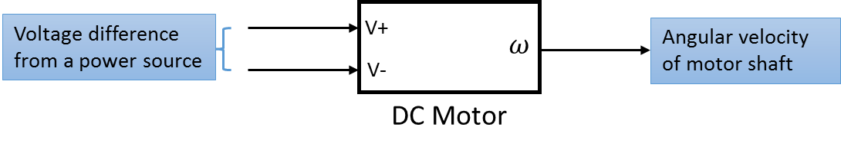

Figure 1**:** Each block is a simplified graphical representation of components or processes in a system. The DC motor in this figure takes a voltage difference as input to produce a motor shaft speed.

In this laboratory exercise you will create a functional block diagram to illustrate the physical, electrical, and programmatic interconnections of an elevator hardware setup. You will model the elevator hardware in a functional block diagram and simulate your model in Simulink and learn of the components that comprise the elevator.

**Exercise 1**

Review the hardware list in the following section (if needed, use Google to research the components in greater detail). After reviewing the components, inspect the elevator to understand how components interact. Create a functional block diagram illustrating how each of the components contributes to the complete system. Create the simplest model possible that captures all aspects critical to the elevator system’s operation.

**Deliverable 1 Show and explain your functional block diagram to your instructor before proceeding to Exercise 2. Note, every block and every arrow MUST be properly labeled!**

**EQUIPMENT**: The following information comes from equipment manufacturer specification sheets

*H-Bridge Quad Power MOSFET Driver for DC Motor Control*

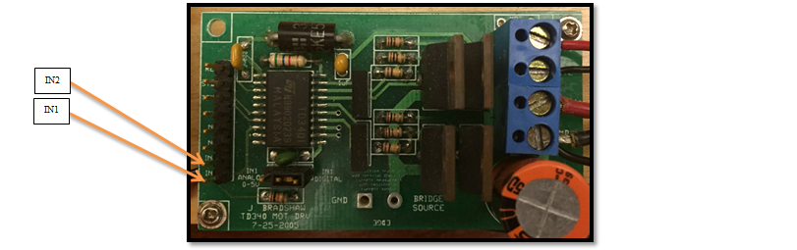

* Allows N-channel power MOSFETS driving in a full H-bridge configuration and is best suited for DC Motor Control Applications. The four driver’s outputs are designed to allow 25kHz MOSFET switching.
* The speed and direction of the motor are to be set by two pins (P26 & P30 or P25 & P27on ES201 Dev Board).
* The H-bridge is capable of driving two motors, however, in this lab only one motor is required.
* The H-bridge is powered by a 12-volt source, denoted by reference voltages V+ and V-.
* The H-bridge takes a 3.3V PWM signal as input and produces a $±12$ V output PWM signal.
* Voltage output is controlled by low side Pulse Width Modulation (PWM). This PWM feature can be made internally when the input pin is connected to an analog signal, or it can be given directly from a digital source.

*Sharp GP2D12 optoelectronic distance measuring sensor*

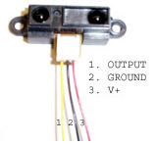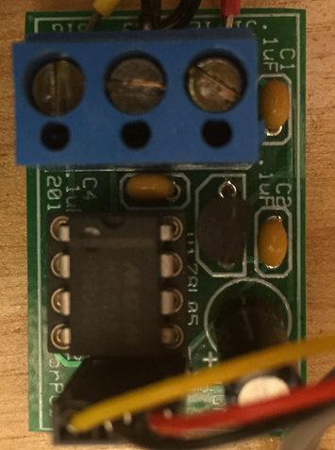

* The sensor is a low current device that relies on pulsed infrared light for ranging measurements.
* The output is an analog voltage that corresponds to a range. Unfortunately, the device will not function properly if it is loaded. To be loaded means there is significant current draw. The A/D converters on your mbed interfere with the sensor by loading it down during the read phase. As such, the sensor is *buffered* using an operational amplifier.
* The buffer printed circuit board (PCB) contains an operational amplifier. The device is optimized for $±5v$ single supply operation. This buffer protects the sensor from the loading effects of the mbed by providing sufficient current from the main power supply to make the A/D work properly.
* Ignore power considerations of the distance measuring sensor in your functional block diagram

*Jameco Reliapro 12V DC motor: HN-GH12-1634T-R*

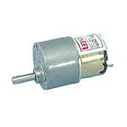

* The DC motor produces angular velocity proportional to the voltage difference applied at the input terminals
* 4.5-12 Volt operating range
* 293 mA current at max. efficiency
* 850 g-cm torque at max. efficiency

*T85 Limit switch*

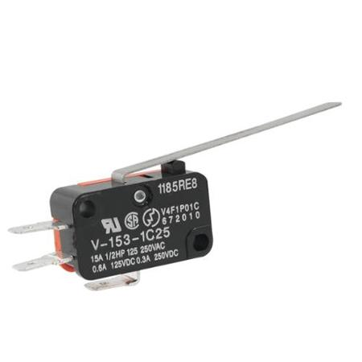

* The T85 limit switch mechanically terminates power from the DC motor when the car reaches a threshold height
* The switch state is naturally closed and opens when the contact lever is pressed

*Elevator pulley mechanism*

* The elevator pulley mechanism converts rotational motion of the DC motor to translational motion of the elevator car.
* The average radius of the pulley (when the car is at 16 inches) is 0.2015 inches.

*mbed microcontroller*

* In this application the mbed microcontroller produces a PWM signal whose duty cycle is user-specified. The duty cycle corresponds to an average applied voltage to the DC motor.
* In later labs, the mbed will take measurements using the Sharp GP2D12 and use the measurements to calculate an appropriate duty cycle.

**Exercise 2**

The functional block diagram created in Exercise 1 is a graphical model of how each component of the elevator interacts with other components. For the purpose of developing control algorithms that drive the system to a desired behavior (such as a desired height), it is extremely useful to develop a mathematical computer simulation model that *approximates* the actual behavior of the system. Simulink is a powerful simulation tool whose programming structure follows similarly to functional block diagrams. In this exercise you will create and simulate operation of the elevator system under user-specified PWM duty cycle generated by a simulated mbed.

**Procedure**

1. Create a working directory folder for MATLAB to use for this lab, e.g., “Lab 12”.
2. Open your Google Drive Folder 🡪 Lab 12 – Elevator FBD and Simulation.
3. Download the contents of the “Mids Files” folder (4 files in total) to your working directory folder.
4. Open Matlab and specify the directory to the Lab12 Files folder location.
5. Open “sys202_elevator_library.slx”. The library contain blocks that represent the components comprising the elevator setup. Each block has specified inputs and outputs.
6. Click the “sys202_elevator_template.slx” file and rename it with a descriptive title for this lab exercise. This file is a blank template upon which you will build your model.
7. Drag the DC Motor block from the Simulink Library into your model. This block contains a mathematical approximation of how the DC motor operates. Double-click the DC Motor block. A window should appear that describes the functionality of the block. Its inputs are the positive and negative reference voltages and its output is the gear shaft speed. The constants represent internal characteristics of the motor that can be modified to make the model better reflect reality. Leave the constants at their default values.
8. Drag the remaining blocks into your model and connect each block according to your functional block diagram from Exercise 1. The arrows in the Simulink model represent signals in the same manner as your functional block diagram. Double-click any block to learn more information about its inputs, outputs, operation, and internal parameters.
9. Change the PWM duty cycle in the MBED block to 0.7.
10. Double-click the integrator block and change the initial height to 7 inches.

In order to view the simulation results, the Library provides two mechanisms to export data. The Scope block 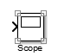 plots the signal data coming into its input port. You can view data after running the simulation by double-clicking on the scope block.

1. Insert three Scope blocks into your model to view the positive reference voltage supplied to the DC motor, the height of the elevator car, and the sensor measurement.

The other mechanism to export data from a Simulink simulation is to send it to the MATLAB workspace. The Send Data to Workspace block 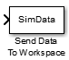 exports the input signal(s) to the MATLAB workspace for further analysis. In order to group multiple signals (arrows) into a single data structure that can be exported, we must combine the important signals in the model. The “Mux” block  takes input signals and combines them into a single data structure

1. Insert a “Mux” block that combines the height signal and the measured value signal from the infrared range sensor. Connect the output of the “Mux” block to the “Send Data to Workspace” block.
2. Run your Simulink model for 20 seconds by changing the simulation time to 20 seconds and clicking the green play button  located at the top of your model window.



1. After the simulation finishes, an animation should appear showing the height of the elevator vs. time. After the animation finishes, save the figure.
2. Double-click the scopes in your model to inspect the data. Does it match the data shown in the animation?
3. Modify the mbed duty cycle to investigate how the response changes with differing duty cycle.

**Deliverables**

This is the first part of your final project report. You should keep record (and shared with your lab partner) all MATLAB and Simulink files, along with any figures and results discussion. You will need this information for your final report. However, you are required to submit a Memo by the due date with the following:

1. A computer generated functional block diagram with *every* block and *every* arrow appropriately labeled.
2. A ½ page, typed explanation of your Functional Block Diagram. Explain each component and how components interact/contribute to the system.
3. A snapshot of your Simulink model with *every* block and *every* arrow appropriately labeled.
4. A printout of the saved figure from your elevator animation.